Transistor Motor Driver

Introduction

This article is about the transistor motor driver that I made:

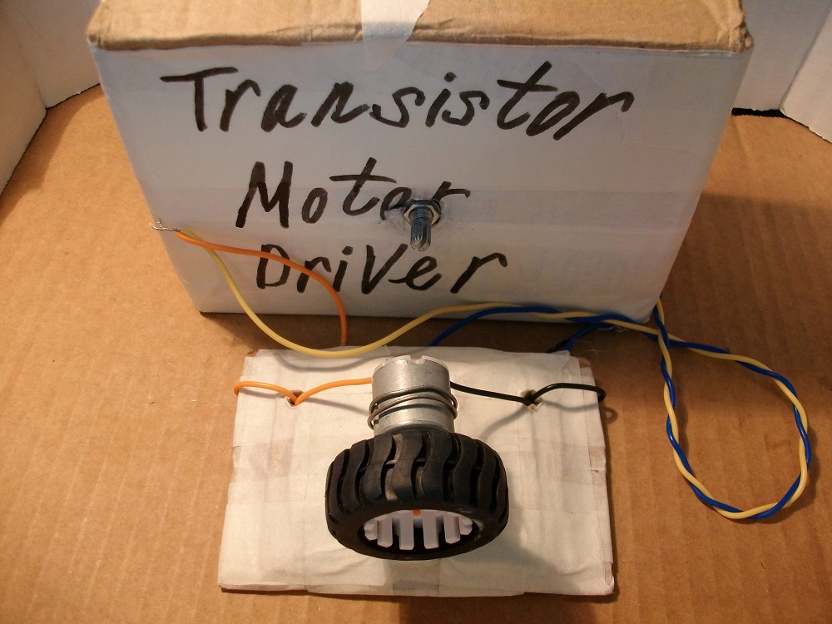
Figure 1: Transistor Motor Driver.

Step 1: Design the Circuit

This is a PSpice simulation software (student edition version 9.1) drawing:

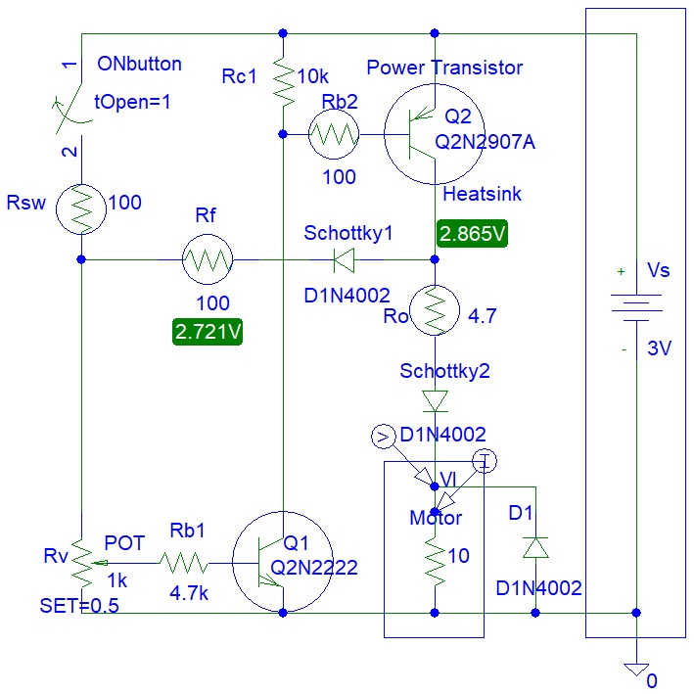
Figure 2: Transistor Motor Driver.

The circuit includes feedback for short-circuit protection. The DC motor input can be short-circuited when the motor movement is impeded. You can watch this short video:

https://www.youtube.com/shorts/9ieu_niV9nM

3. Step 2: Simulations

Simulations show a high current output:

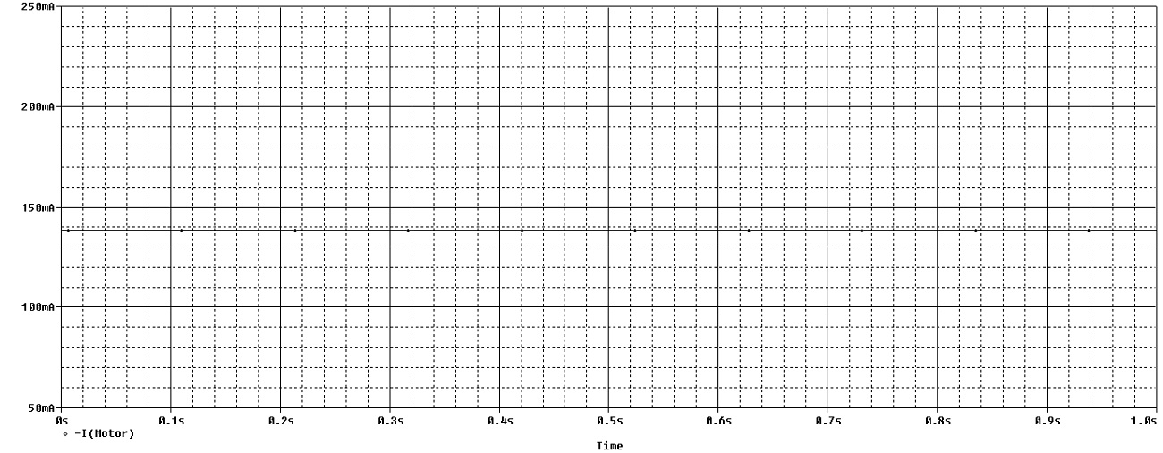
Figure 3: Transistor Motor Driver Simulations.

Step 3: Make the Circuit

Not all the components shown in the drawing were included in the actual circuit construction.

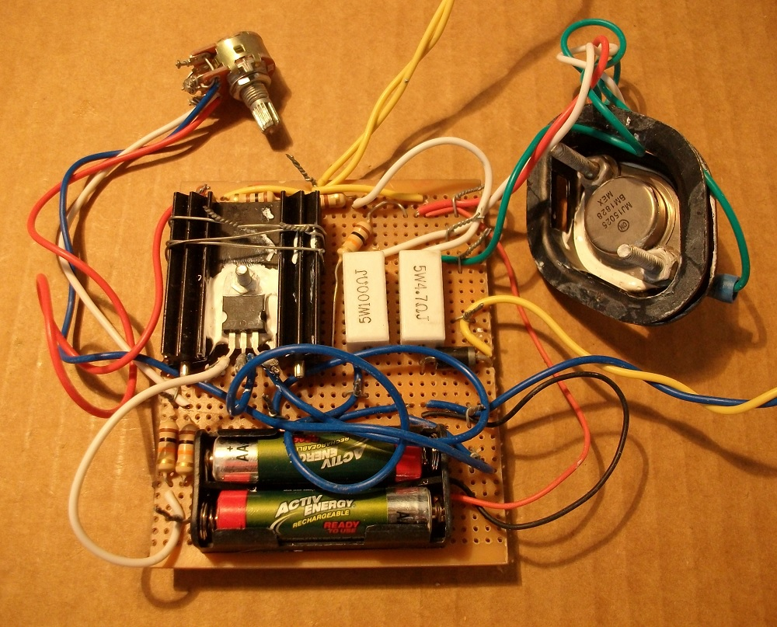
Figure 4: Make the Circuit.

Step 4: Encasement

I used an old parcel cardboard box for encasement that you see in the photo.

Conclusion

The motor driver needs a big heat sink because sometimes the Q2 transistor is not fully saturated.

Adam, Weird Circuits Project

